

Summer Rock 2016

Climbing Instruction Programme

Wellington Section NZAC

The Wellington section of the NZ Alpine Club has been running summer rock courses for over a decade. Our mission is to promote safe, fun climbing and to encourage new climbers. Our team of instructors includes certified instructors and climbers with lots of experience in NZ and abroad. We are all volunteers.

Course Aims:
- Providing you with an introduction to gear and techniques for safe rock climbing, covering top rope climbing, abseiling, and starting to lead climb on rock.
- Helping you progress from indoor climbing to an outdoor climbing environment.
- Introducing you to North Island climbing - bouldering at Baring Head, and two great weekend trips to Taupo and Waikato crags.
- Introducing you to other keen climbers and the Alpine Club.

Skills Learnt:
- Safe practice: knots, belaying, gear
- Top rope belaying and lowering
- Movement and efficient climbing
- Abseiling
- Top rope anchors
- Lead belaying and climbing indoors
- Anchor rethreading and abseiling
- Lead climbing on rock

Course Structure:
- Six nights at indoor climbing wall (HangDog or Fergs).
- Day trip to Wellington's beach-front bouldering at Baring Head.
- Weekend trips to two of the best climbing areas of the North Island: Kinloch - a great crag on the shores of Lake Taupo, with a 5 minute walk from our holiday home accommodation, and Wharepapa South - Waikato volcanic crags with a great range of routes for all levels.

Requirements:
- You have to be a member of the NZ Alpine Club. For membership details, see http://alpineclub.org.nz/membership
- Previous climbing experience is useful but not necessary.
- You will need to have your own rock shoes. We can provide harness, carabiners, slings, belay devices and helmets, but please bring your own if you want to. Email us for more details. We advice you strongly to wait or contact us if you intend to buy gear.

Cost and Registration:
- The course is run on a cost recovery basis: $710.00. Covers: travel, accommodation and BBQ dinner for weekend trips, climbing gym entry 6 nights, access to Alpine Club equipment.
- Course limited to 12 participants. To register, email: jadriacincotta@gmail.com

Photos from last years courses:
- Wharepapa South 2014 climbing week-end
- Baring Head 2014
- Wharepapa South 2013 climbing week-end
- Kinloch 2012 climbing week-end
- Wharepapa South 2012 climbing week-end

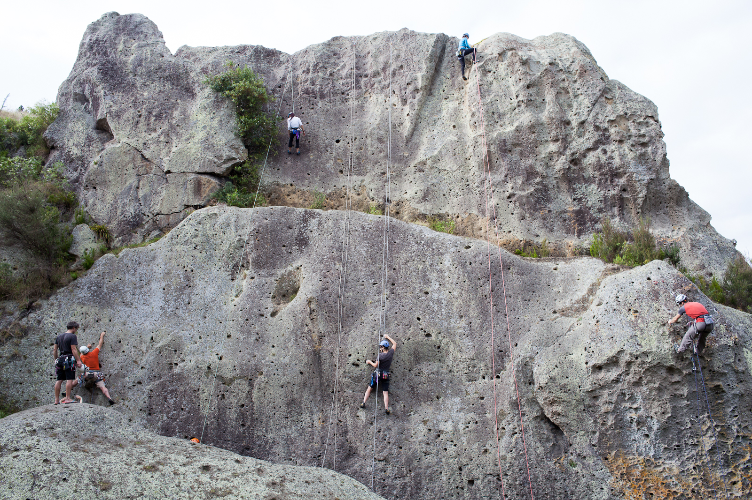
Wharepapa South, Waikato, Summer Rock 2012

