Australia Section Inc. Reg. No A0047513N
CHAIR REPORT
APRIL 2022
- The Chair Report

The Section has finally kicked off its 2022 program of outdoor activities. There were some initial delays, but we are now up and running for 2022.

The program, as outlined below, has a variety of quality activities listed and ones that have proven very popular with members in the past, such as the mountaineering meets in Kosciuszko NP. Let’s see how many friendships we can renew at these meets. Hope to see you there soon.

The first Section activity for 2022 occurred on the weekend of 19-20 March, when eight Section members attended a rock climbing meet in the Blue Mountains organised by Peter Blunt, a Canberra based member. Some of the Section’s climbing stalwarts dusted off their climbing racks and agreed to be part of this climb, and with a combined total of some 200 years climbing experience, made the meet a quality experience. Imagine the learning opportunities for younger and/or inexperienced members who attended the climb. Where else would you get ready access to such climbing experience? Considerable time was also devoted to skill building workshops, which provided hands-on demonstrations & practice of a variety of climbing skills.

COVID has certainly put a dent in our enthusiasm to get outdoors with the danger of possible exposure to the virus. With the current vaccination program now in place and the relaxing of restrictions it is now an appropriate time to get back into the great outdoors. Whilst members tend to use social media to connect on a day to day basis, the Section’s activity program is a great tool for members to plan trips ahead and then meet up.

The Section wishes to connect with members of all demographics and ages and promote all types of climbing related activities. We appreciate any feedback from members regarding the types of activities on offer and are happy to include new ideas about what might appeal best to members. The Section’s activities are varied or multi-disciplinary in nature as it is difficult to keep a focus on mountaineering in Australia when we have very little to offer locally in the way of mountaineering activities.

We also look forward to welcoming some new members on the management committee as we move forward into a new period of renewed enthusiasm and determination to go climbing more often.

- Annual Activity Program
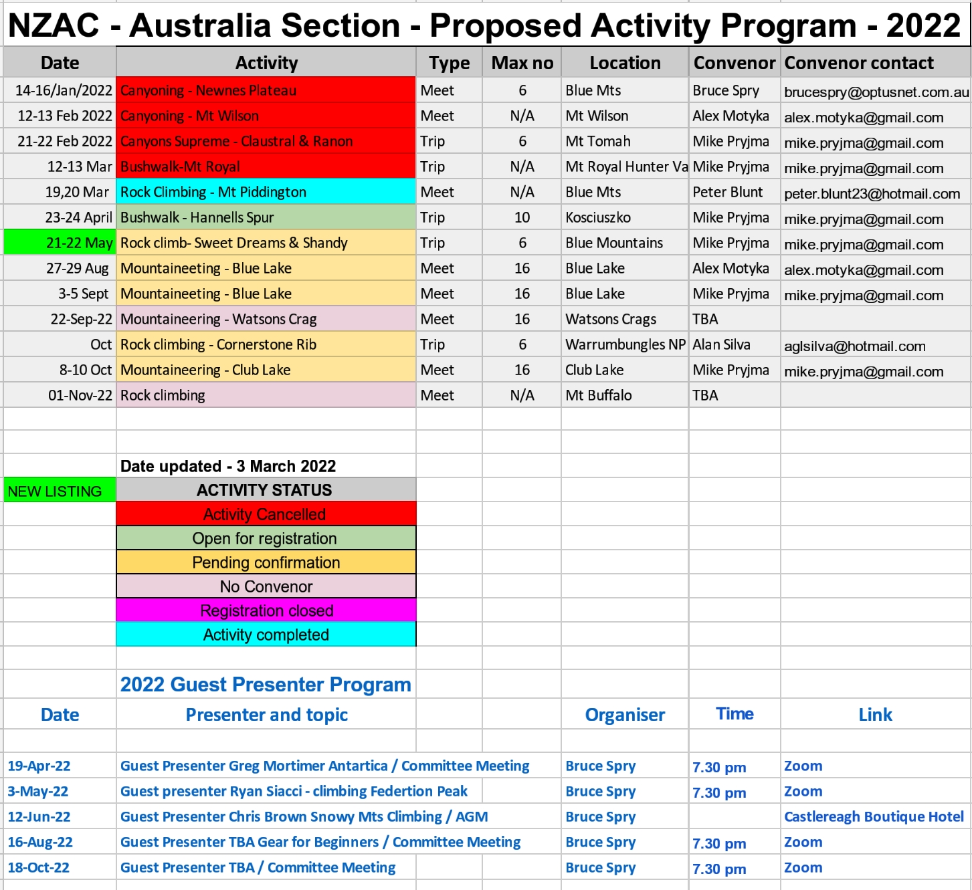

- Online Presentations - upcoming

- Greg Mortimer – Antarctica – expedition to Mt Minto - 19 April 2022

Greg Mortimer well known for climbs in the Himalayas including Everest, K2 and currently leading Aurora Expeditions trips to Antarctica will provide the story behind an early expedition to Mt Minto in in Antarctica.

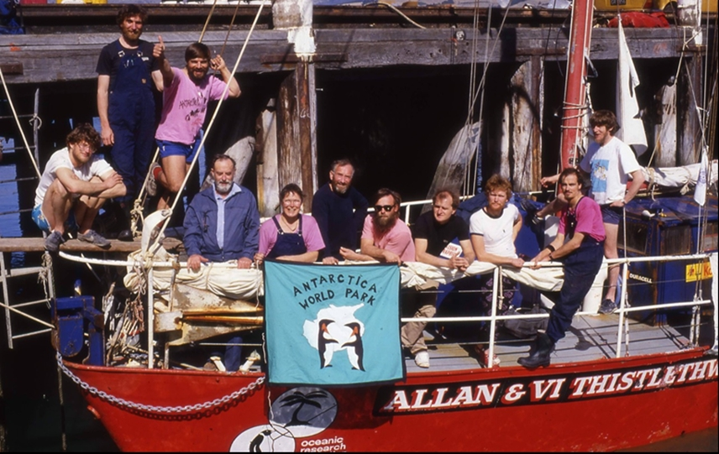

- Ryan Siacci – climbing Federation Peak, Tasmania – 3 May 2022

Famously described by Ed Hillary as "Australia's only real mountain", Federation Peak is a brooding monolith guarded by the rugged Tasmanian Southwest wilderness. First climbed a mere four years before the other mountain to which Hillary's legend is attached, Federation Peak retains a reputation for remoteness and adventure even in the modern era. It's about as close to alpine climbing as you can get on Australian shores and a worthy goal for any adventure climber. Last January, Alex Mougenot and Ryan Siacci sallied forth into the wilderness, climbing Federation Peak via Blade Ridge and the Northwest Face. They enjoyed five spectacular days of vegetation, mud, choss, torn pants, golden curry, life lessons, minor failures, and ultimately, a successful ascent of
Federation Peak.
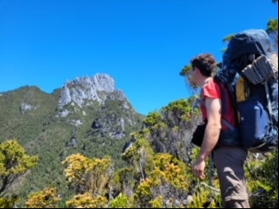
Make sure you tune into these presentations. More interesting presenters/adventures are coming.
The updated program is listed above. This is a works in progress and will be periodically updated during the year & details will be notified to members via this monthly report.

As always, if you have any feedback or questions about the program please contact the Events Coordinator on australia.events@alpineclub.org.nz

Members seeking additional information or wishing to register for any of the activities should also contact the Activity Convenor via the email address listed in the program. For all other matters relating to the program contact the Events Coordinator on australia.events@alpineclub.org.nz

Members willing to put together a short online presentation please contact the Secretary on australia.secretary@alpineclub.org.nz

The committee would also like to hear from members willing to prepare a short report (with photos) of a recent climb, walk or canyon for publishing in this report. It’s often quite inspiring to read accounts of other people’s adventures and we look forward to receiving some transcripts.

- Blue Mountains Climbing Meet – 19-20 March 2022
Meet Convenor: Peter Blunt
The program was jam-packed with adventure comprising a variety of formats – climbing, skill development workshops, climber coaching, evening presentations and big wall portaledge demonstration.
Despite drizzling rain on Saturday and into the evening, the team ventured to the classic Mt Piddington, a site littered with many historic trad climbs, where they enjoyed relatively dry rock under a convenient overhang for some crack, corner and a steep face climbing. Despite being sheltered from the rain the very high humidity conditions meant that shoes did not grip quite as good as in dry conditions.
Skill development sessions on abseil safety systems, belaying off the harness and off the anchors, locking off, escaping the system, top and bottom belaying and pull down abseils were held.
Saturday evening was a social gathering under the tarp and saw two presentations:
- Darran Mountain traverses in Fiordland, NZ – Ian Brown (Blue Mountains based NZAC member, climber, bushwalker, naturalist, conservationist and nature photographer.)
- Bigwalling The Nose of El Cap and Ozymandias, USA – Peter Blunt (Canberra based NZAC member, educator and climber.
These presentations were supported by many quality photographs on the big screen (well, laptop)
Sunday saw the return of fine weather and the team travelled to Mt Boyce for some beautiful mixed long 1 and 2 pitch routes on the main faces and including the stunning Eyrie arete.
Further skill development sessions were held on trad lead climbing, multipitching and portaledging. Peter Blunt also set up his portaledge on the face adjacent to The Eyrie arete to demonstrate ‘life on a big wall’.
The weekend was an extraordinary success on many levels. The depth and quality of climbing experience present was outstanding and the sharing of that experience extensive was greatly appreciated. The in-depth knowledge of the climbing areas visited was also invaluable with respect to history of the crags as well as in assisting members select suitable climbs. Those who were previously educators in their previous life thrived in the teaching environment of the skill development workshops. The cooperation and collaboration was impressive.
Thanks to all who led, mentored, coached and supported others. Your generosity, commitment and experience was much appreciated.
Finally, a big thank you to Peter Blunt for organising such a successful meet, but we do appreciate that he had 2 years to do this! (delayed a couple of times with COVID restrictions)

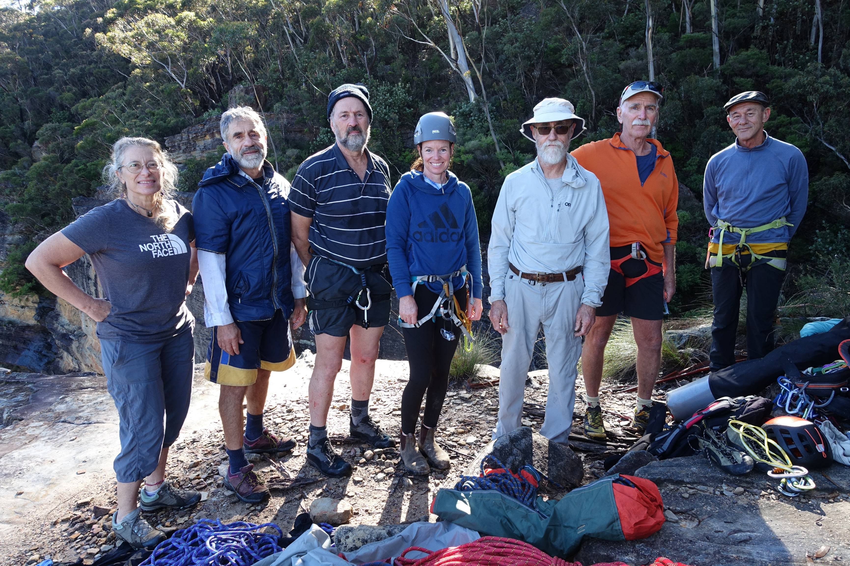
The ‘Team’ (excluding photographer) – over 200yrs climbing experience Photo by Mike Pryjma

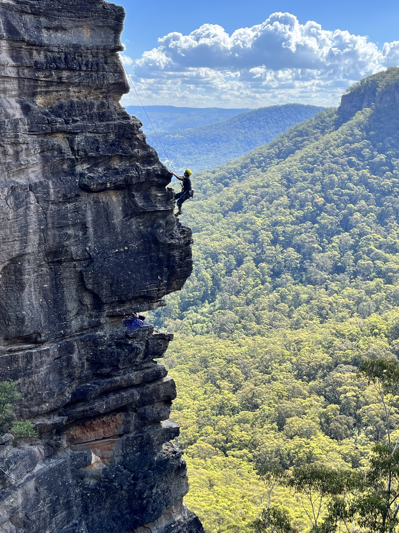
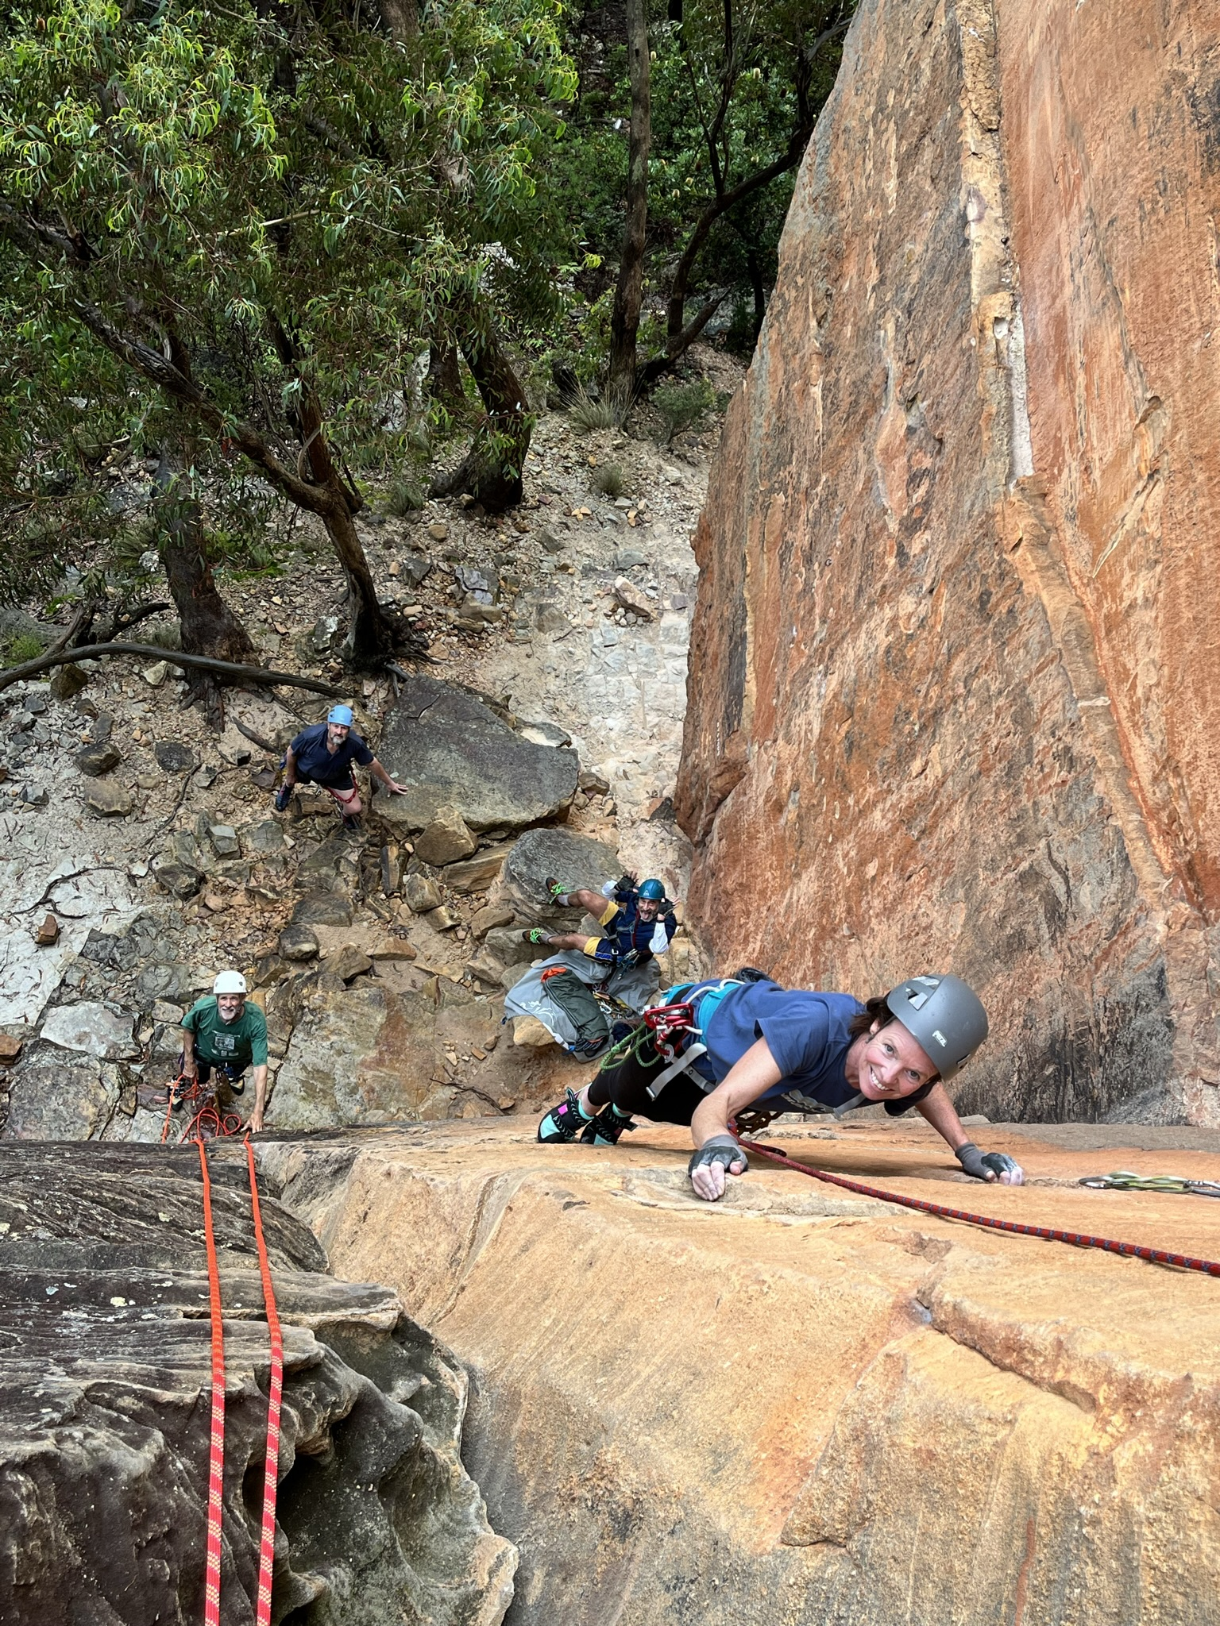
Some big wall action Photo by Peter Blunt The Eyrie arete Photo by Peter Blunt
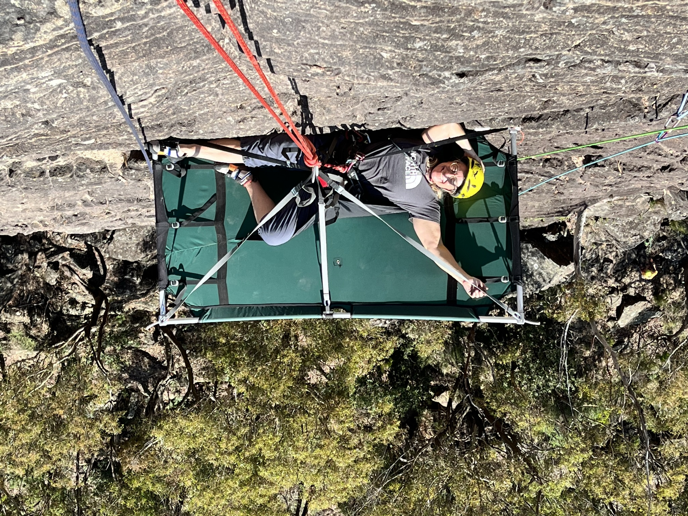
Life on a big wall Photo by Peter Blunt

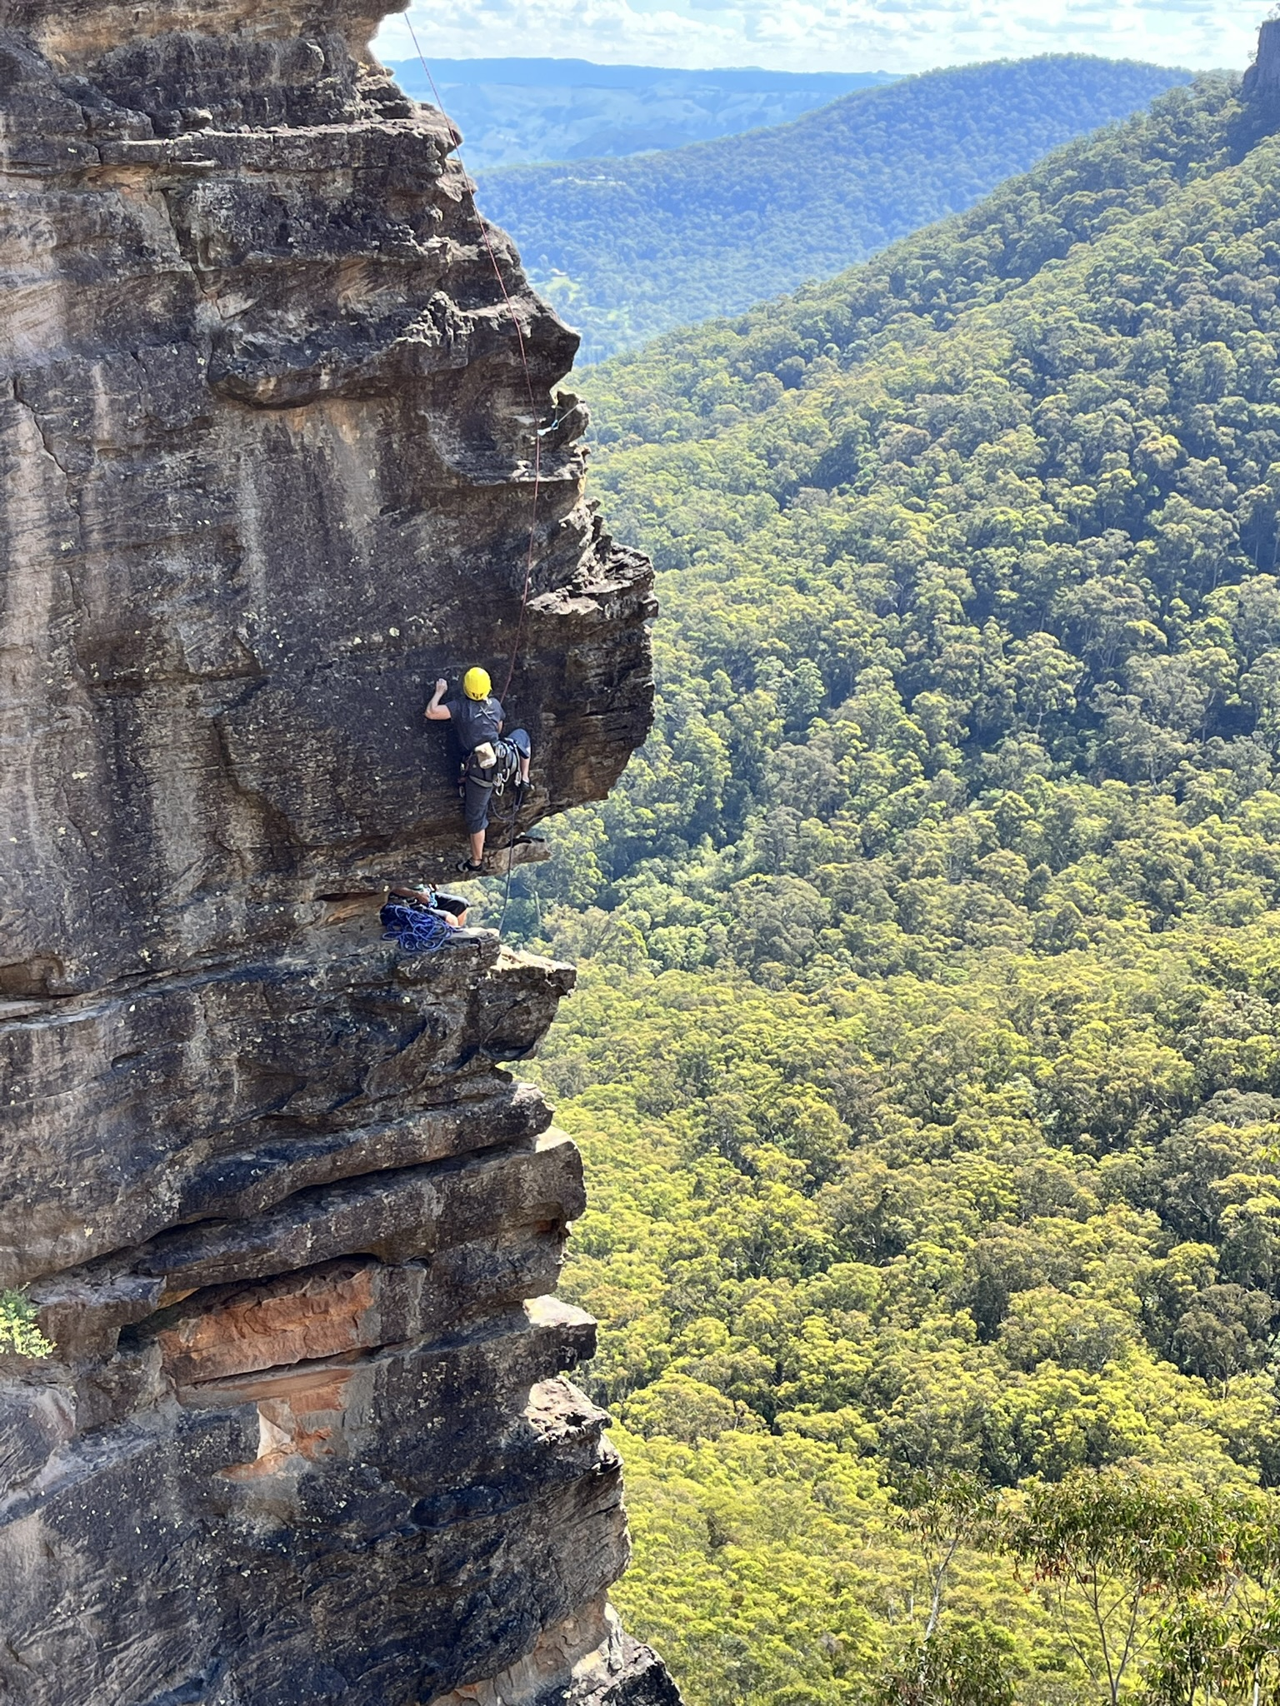
Exposed move on ‘The Eyrie’ Photo by Peter Blunt

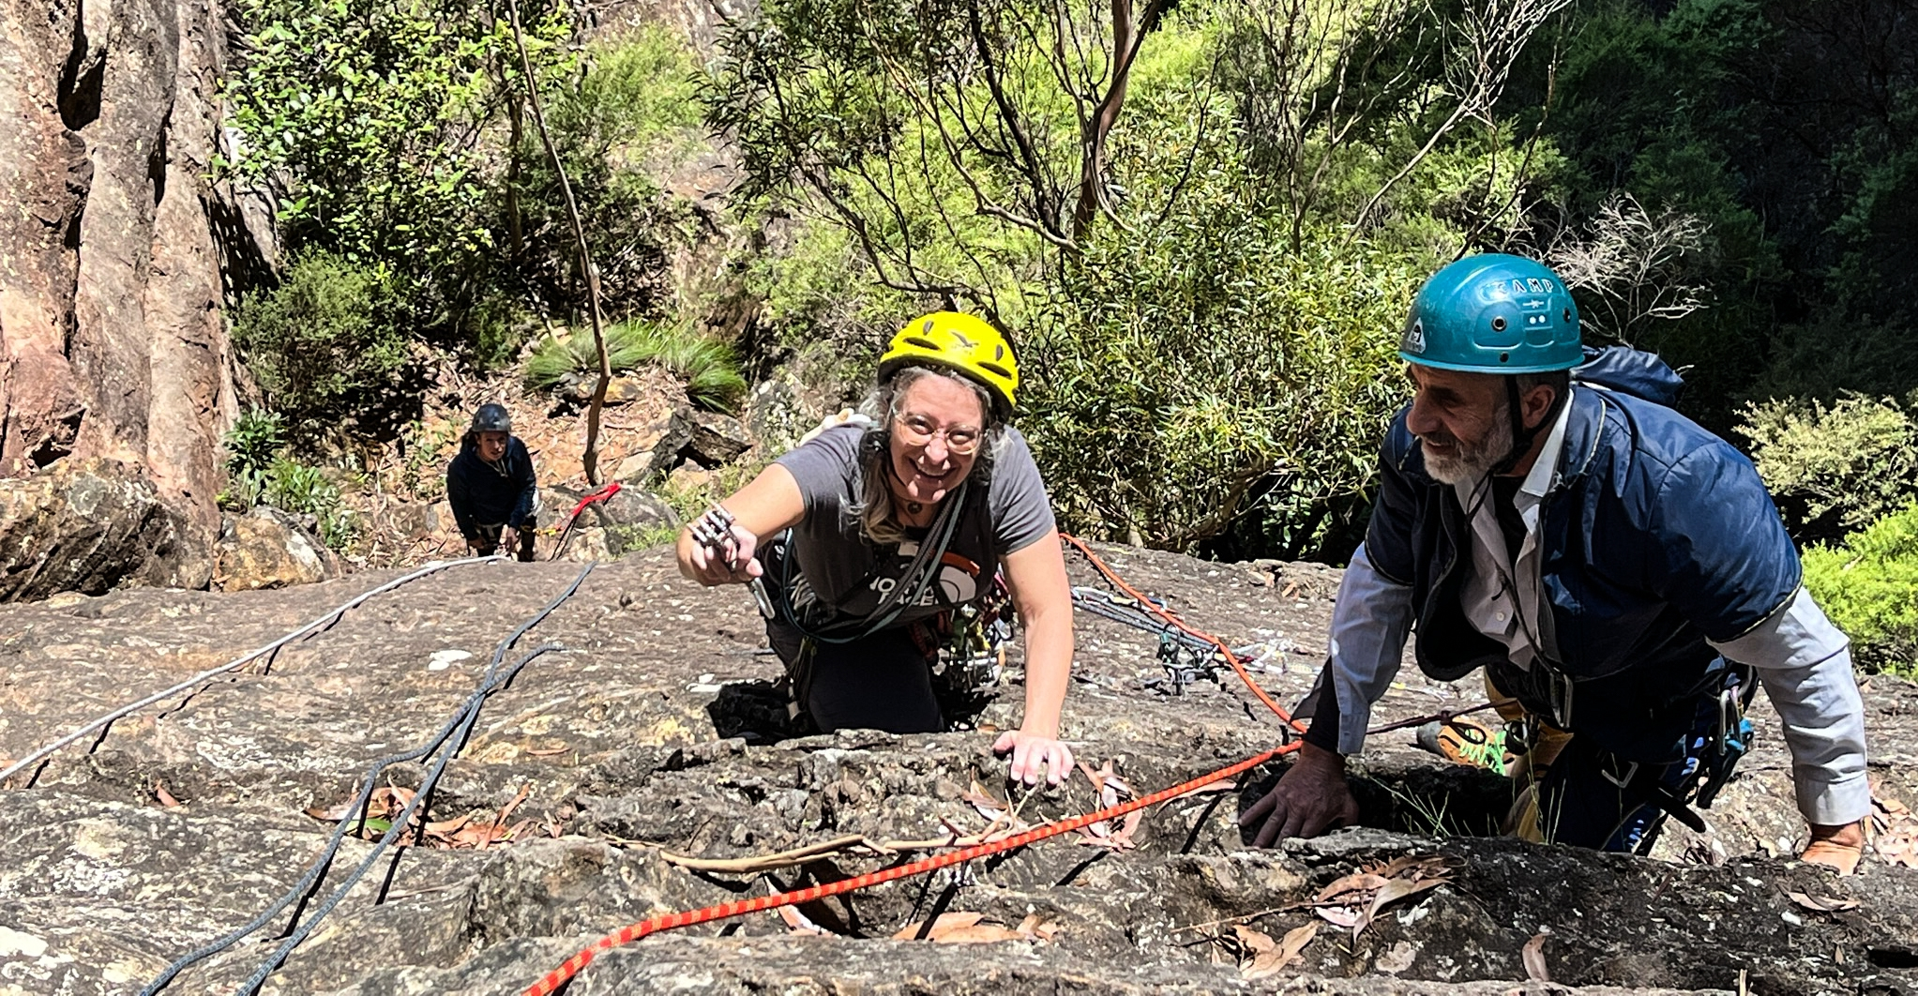
Trad gear placement workshop Photo by Peter Blunt

- On Staying Safe in the Mountains - How Not 2!

Keeping Safe whilst Abseiling

The art of abseiling (rapelling) is a common technique across a wide variety of adventure sports, which NZAC members participate in – rock climbing, mountaineering, caving, canyoning.

It is also potentially the most dangerous component of such activities and it is easy for something to go wrong. But it is also just as easy to avoid the pitfalls. Knowing what the actual pitfalls are helps us focus on the priority actions during abseiling.

In 2018, a review was undertaken in USA of all accidents in American mountaineering. The results were published in the American Alpine Journal. This was an extremely informative review, which provided much needed clarity and direction on how to stay safe whilst abseiling.

One disturbing finding was that accidents were happening across all experience levels, even professional guides. It appears that over-confidence, complacency or failure to do proper checks could be an issue across the board.

Common identified errors during abseiling were:

Error 1 – abseiling off the ends of the ropes – 30% of accidents
Error 2 – Anchor failure – 25% of accidents
Error 3 – Losing control on abseil – 20% of accidents. Many things can cause this:
Falling rock/ice, pendulum swing, skinny slippery ropes, icy ropes, not enough friction on device, human error (fatigue, dehydration, distraction, sickness)
Error 4 – Inadequate or no safety connection to anchor – 10-15% of accidents

Remedial actions:

Error 1 – always tie a stopper knot in the end your rope, such as a fishermans knot or figure 8– except where this might present a problem eg swift water canyoning situations where you might need to get off the rope quickly

Error 2 – build solid anchors
- Double check anchors before use + buddy check when appropriate
- If in doubt, back the anchor up with an another piece

Error 3 – belay abseiler from below, and/or
- backup the abseil with a running friction hitch (autobloc) – extend the abseil device and attach a French prusik below the abseil device & attach to belay loop. It is not recommended that you attach the prusik to the leg loops – refer to procedure below

Error 4 – always attach yourself to the anchor via a safety line during all setup and transitioning or whenever close to a dangerous situation.
- Always test your abseil setup prior to unclipping your safety line.

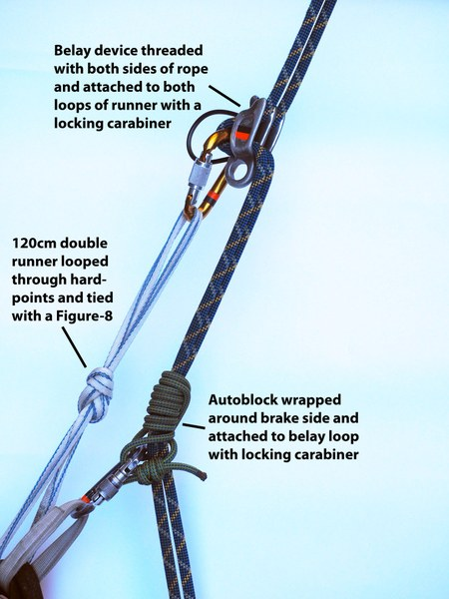
Setting up an extended abseil
- Attach autoblock to belay loop with its locking carabiner
- Pull rope up through autoblock to form bight of rope for threading device -the autoblock holds the weight of hanging rope strands.
- With device located as close to anchor as practical thread rope bight through rappel device.
- Clip device into both distal extending sling loops with carabiner.
- Lock the carabiners.

- Positions Vacant

Currently the Section is seeking interest from members to fill three positions:

- Treasurer
- Newsletter Editor
- Safety Coordinator

These are vitally important roles within the Section administration. Please consider making a positive contribution to the management of the Section.
For further information or to express an interest in these roles please contact me on australia.chair@alpineclub.org.nz

- Obituary – Andrew Mitchell

Sadly, I inform members of the passing of long time Melbourne based NZAC member, Andrew Mitchell, who suddenly passed away in December 2021 after a relatively short illness.

Andrew was an active and experienced member, who also made significant contributions to the management of Australia Section through his involvement in the management committee including performing the role of Victorian Coordinator and Convenor of the Technical Advisory Panel during the period 2016-2019.

Andrew's passion for outdoor adventure and supporting NZAC as an institution was self evident and quite extraordinary. He was the most prolific contributor to our annual trips program in Victoria as well as an inspirational ambassador of the Club.

Andrew was a very professional, committed and dependable member of the management team. Throughout this period I got to know Andrew very well during my time as Chair, Australia Section. I personally met Andrew in 2018 when he joined the Section trip to Empress Canyon that I organised.
Andrew will be fondly remembered for his energy, commitment and contribution to the Section.
On behalf of the Section, I wish to extend our deepest sympathies and condolences to his wife, Julia, other
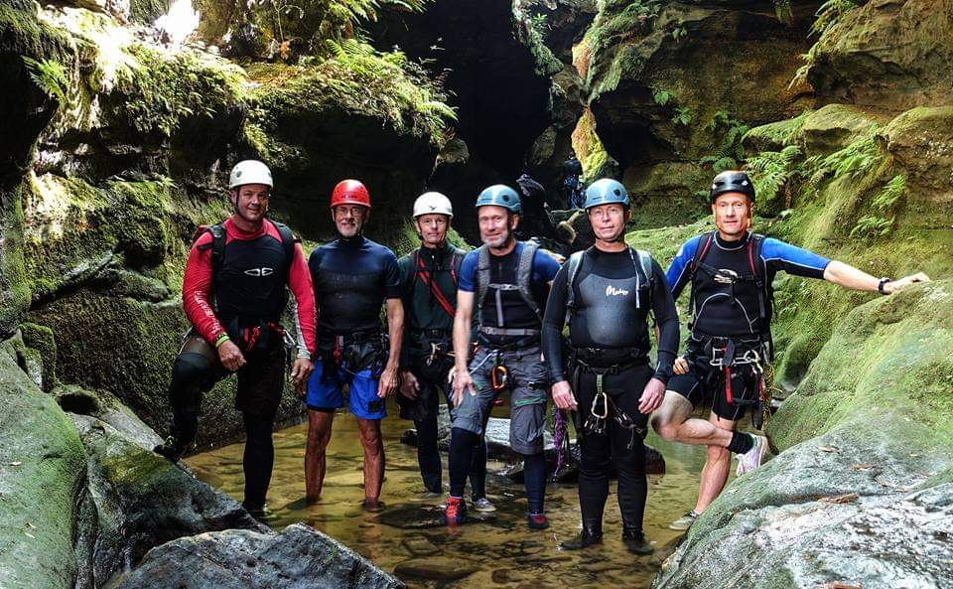
family members and friends.
NZAC Empress Canyon trip 2018 – Andrew Mitchell far right. Photo by Mike Pryjma

- Member Benefits

One of the many benefits of NZAC membership is a variety of discounts available to members:
- Macpac discount – 30% off all Macpac branded products
- Subsidised equipment hire for avalanche transceiver/probe set
- Club Activity program - club trips both within & outside Australia – opportunities to meet climb partners
- Subsidised membership of selected indoor climbing walls & discounts at selected gear shops
- $200 subsidy for mountaineering training in Australia – contact committee for conditions
- Online Speaker presentations - renowned & interesting mountaineers/climbers
- NZAC branded clothing merchandise – including shirts, hat & caps
- Discounts on many backcountry huts in NZ
- Publications from NZAC – Alpine Journal – two per year
- Snowy Mountains Climbing School (SMCS) offers 10% discount on its rock climbing and 6 day introductory Mountaineering courses. Further details are available on their website http://www.snowymtns.com/education

- Management Committee
Chair: Mike Pryjma (NSW)
Vice-Chair: Warwick Williams (NSW)
Secretary: Bruce Spry (NSW)
Treasurer: Peter Blunt (ACT) (interim only)
Newsletter Editor: Vacant
Online Coordinator: Michael Macdonald (NSW)
Events Coordinator: Charlie Freer (ACT)
Member Services: Anthony Brandis (WA)
Safety Coordinator: Vacant

Details about Australia Section can be found at https://alpineclub.org.nz/region/australia/

With your help & cooperation, we can continue to build confidence in the Section and the activities we offer. Thanks everyone for your help and support.

Mike Pryjma
Chair, Australia Section

